Scheduled TV for ITV System
Product Design Specification
Revision: 0.2
Author(s): Hui Shao
Date Last Updated: 2004-10-11


124 Acton Street, Maynard, Massachusetts 01754
Phone: 978-897-0100
Fax: 978-897-5065

Revision History
Revision | Date | Who | Description
0.1 | 2004-7-27 | Hui Shao | Initial draft
0.2 | 2004-10-11 | Hui Shao | Sync/collected module design from team members
0.3 | 2004-10-14 | Hui Shao | Configuration, manutil and detailed failover process

Table of Contents

Contents
Revision History ii
Table of Contents iii
Contents iii
Overview 5
Related Documentation 6
Design Status 7
Constraints 7
Operations overview 8
Operations scenarios/scripts 8
System performance considerations 8
Detailed Design Specifications 9
Functional Hierarchy 9
Data Flow Description 9
General Conventions 10
Scheduled ITV Application Service 12
Program Structures 12
Input 12
Service Configuration 13
SM Command Messages 13
Timepoint Events 15
Stream Events 15
Stream Operation Events 15
RTSP Responses and Announces 15
Process 15
PlaylistManager Control Loop 16
SM command process 17
Launch a Channel 17
Responses Stream Status Changes 17
Keep Alive and Failover Process 18
Output 19
Modules 19
Playlist, PlaylistManager and Playlist DB 19
AutoFiller and BarkerFiller 21
Schedule Manager Connector 22
RTSP Client 23
Stream Session 25
SeaChange Service Framework 26
Installation and Documentation 27
Error Codes 27
Maintenance Utility Description 27
ManUtil 28
Installation and Deployment 30
Installation Automation 30
Deployment and Pair Backup 30

Overview
The Scheduled TV system is intended to deliver uninterrupted linear scheduled streams in ITV VOD configurations. Delivery of content is consider “output only” in that it is derived from a customer supplied schedule detailing exactly what assets are to be played, when the assets will air, and what specific services the asset will stream over. Scheduled services are autonomous in that they will stream assets in the sequence defined by the schedule without regard to how many end users may be tuned in to the service. End user consumers will have the ability to tune in or join a scheduled service based on external conditional access but will have no ability to request specific content, manipulate the service via set top controls, or otherwise influence the delivery of the content being streamed over the service.

Scheduled TV extends and enhances the ITV platform by delivering the capabilities and functions most commonly found in Near Video On Demand (NVOD) systems. Schedule TV will enable the ITV platform to deliver scheduled content on a pay per view event basis, stagger cast broadcasting, repetitive event scheduling, per day event scheduling, randomized and serial barker or carousel channels, and load balanced feature scheduling.

Scheduled TV is also an enhancement of the current SeaChange VOD Barker system. SeaChange VOD Barker system employs the robust and feature-rich VOD Command Center components to deliver barker channel services. Hence, the operator uses familiar tools to deliver the barker channels. These sophisticated management tools enable the operator to operate their systems from near or afar. The existing SeaChange Barker Channel product has three major limitations that are impeding the wide spread acceptance of this product within the SeaChange VOD installed base (as well as the ability to sell it to non-SeaChange VOD customers). These limitations are expected to be removed in the Scheduled TV Barker Channel. Specifically, they are:
  - The RunBG utility is used to generate the barker channel stream from the SeaChange VOD system. If the VOD Barker server or the RunBG application terminates then the stream will discontinue until the operator restarts the RunBG program. In other words, there is no automatic restarting of the stream if the initiator (RunBG) terminates.
  - The operator must edit the RunBG input.txt file to create the list of what assets are played out of which barker outputs.
  - Content is played back-to-back without any concern for the integrity of the MPEG stream; i.e. there is no splicing. Hence, the content must be encoded to fade to black at the end in order to ensure proper back-to-back playing of the barker channel content.

The following components will be included in the Scheduled TV implementation for ITV system:
  - SITV (Scheduled ITV or Scheduled TV for ITV)
An ITV application service that enhances standard ITV system by adding the capabilities in NVOD and Barker system
The SITV and SITV cover the interactions with the standard ITV system. They also work with SM (schedule management), a schedule/playlist management user interface, to response schedule or playlist administration.

Related Documentation
Provide a list of related documentation and locations where they can be found.

- Product Requirements for Scheduled TV as Part of the SeaChange Barker System, Rev 0.2, Steve Davi
- Scheduled TV Features Description(DRAFT), Deb Dalton, Anwa Huang, Dan Powell
- SeaChange ITV Scheduled TV, ZQ draft
- SeaChange VOD Barker System Version 1.6 SPD Revision 1.2
- SM Interface with Ingest and Playback, 1.0.4, Hancel.Shao
- SeaChange Interactive Television Real Time Streaming Protocol Client Interface Specification (DRAFT) Revision 1.5.0, Nancy Wimberg, Gregory Holbrow, Jim Baratz
- RTSP CLIENT CONTROL MODULE (RTSPCLIENT) Module Design Document by Bernie Zhao
- PLAYLIST AND PLAYLIST MANAGEMENT Module Design Document by Bernie Zhao
- SMInterface Detailed Design Document.doc by Jie Zhang
- SM Interface with Ingest and Playback by Hancel Shao

Design Status

Constraints
The SITV program must run as a Windows service using the SeaChange Service Shell and App Shell, and be able to run on Windows 2003. The program must be configurable through the ITV Configurator service, and must support ManUtil interface and SNMP.
SITV must provide all the functionality currently available in the SeaChange Barker Channel product.
SITV must allow import of content without all of the normally required metadata, which can probably achieved by creating a new Asset Manager plug-in, SITVPlugin).
SITV must work with SM, the user interface of schedule/playlist management, for ease of operator control for definition of assets that are part of each streaming. The interactions was defined in SM Interface with Ingest and Playback
SITV must provide for smooth transitions between assets and limit the number of non-smooth transitions to a very small number. Specifically, it MUST use the smooth splicing capabilities of VOD v2.0.
SITV must process as many simultaneous channel requests at once as possible (typically 20).

Operations overview

Operations scenarios/scripts

System performance considerations

Reliability
As a service, SITV inherits all the reliability from a standard SeaChange VOD service. All threads used in the program will be pooled by invoking SeaChange’s ScThreadPool.dll. SITV provide dual rail network support when communicating with other VOD Command Center components, and provide an effective app-shell keep-alive test
Compatibility
As a standard SeaChange service, the new service will has interfaces to ManUtil, alarm, pager and other standard SeaChange utilities. Besides them, the new service will not require additional ITV components to work, in other words, it has minimal dependents to run.
The new service can work on the existing ITV deployment without requiring additional hardware.

Detailed Design Specifications

Functional Hierarchy

SITV works as an additional ITV application service. It invokes ITV ISSAPI to provide dynamic playlist and limit the non-smooth transactions between assets, and it sinks the streaming events from MCA, SRM, CM.
SM interface and local schedule management subsystem of SITV exchanges schedule or playlist data and the play status with SM(Schedule Management), which provide an easy-to-use web-based user interface.
SITV also has its internal RTSP client module to start a stream on ITV based on the time points of the active schedules. It can manages multiple schedule sessions

Data Flow Description

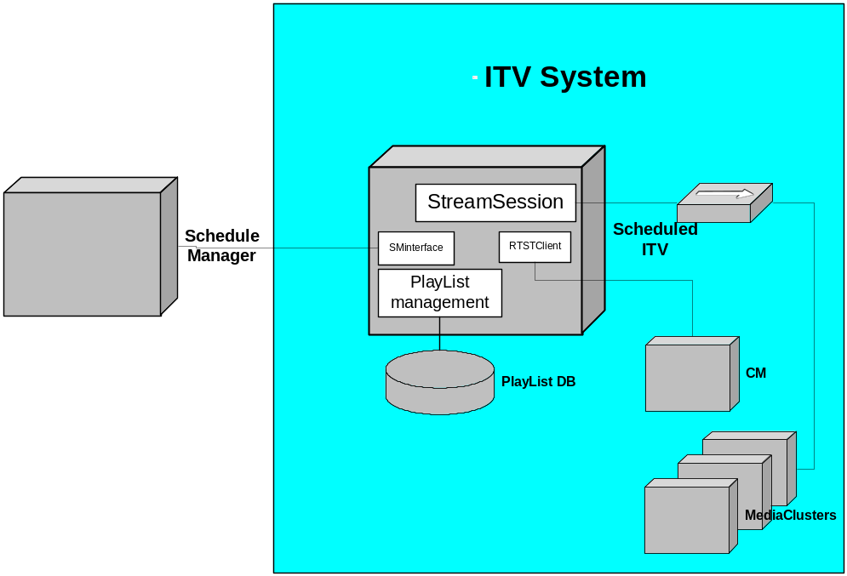
Figure 4.1 SITV deployment and components

SITV is a SeaChange ITV application service that will be installed in one or two of the ITV command center cluster. It also can be installed separately in an additional box with the command center LAN.
The following describes the data flow briefly:
- SM sends playlist to the SITV thru the SMInteface
- The playlist managemet creates playlist to associate the new playlist and maintain the data with the external DB
- When a channel start timepoint is met, the service kick off a stream by sending RTSP requests to the ITV CM via the RTSPClient module
- A new StreamSession is created to response the ISSAPI newstream callback
- The StreamSession associate the related playlist and apply the asset scheduled in the playlist to that ITV stream by invoking ISSAPIs
- The StreamSession also monitors the status change of the ongoing stream

General Conventions

Term | Description
SITV | The scheduled ITV applicaton service name, also it is the main service class name, SITV.exe will be the targe service image filename
SITV service | See SITV
SM or Schedule Manager | The web-based UI system that provide program schedules to SITV. Also it works as the management UI.
Channel | The channel in this document is a combination of an IP address and a port number that a stream pumped on. The IP address can be unicast, multicast or broadcast address. For example, 225.12.12.12:1000
StreamSession | An manageable object to associate an active stream pumped from ITV system. It also includes the operation methods of that stream
Timepoint | To describe the clock-based events in program schedules
Playlist | List of media asset about to play on specific channel

Scheduled ITV Application Service

Program Structures
The component structure of the system will be like the following:
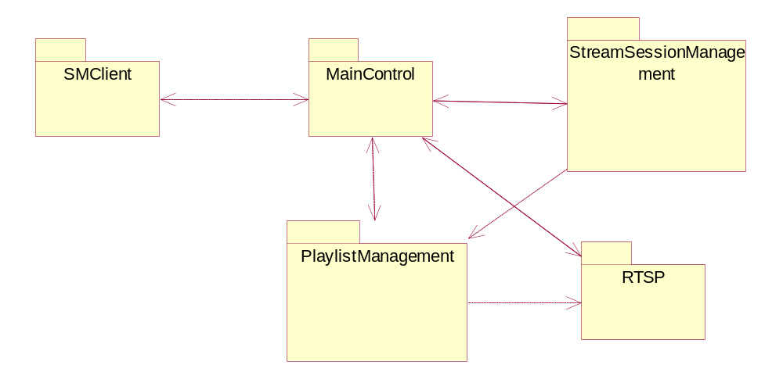

Input
Provide a detailed description of valid user or program inputs for this function.

Service Configuration

Service Configuration
McastFwd has two-level configurations: standard SeaChange CfgPkg variables that are registry-based and external XML-formatted configuration
Registry-based variables

name | description
MirrorDirectory | The first release of SITV use a set of disk files as the mirrored database for the playlists.  This configurable option let administrator to specify where to put the mirror files
MirrorFileExtname | The file extenstion name of the mirror files
FillLength | The number of minutes that a playlist will be filled by the filler
ScheduleManangerAddr | The IP address where the Schedule Manager Service installed
ScheduleManangerPort | The port number that the Schedule Manager Service listens
InstanceID | The INST id of the SITV installation
ApplicationUid | The application UID when the SITV registered to the AM
RTSPServerAddr | The IP address where the ISRM installed
RTSPServerPort | The port number that the ISRM serv as a RTSP server-side
RTSPFrequence
RTSPTimeout | Timeout to waiting for a RTSP response
DummyAssetUid | To specify the dummy asset to bring up a stream
LogFile | …
…

SM Command Messages
They are received from SMInterface. See SM Interface with Ingest and Playback for more detail.
The message can be divided into 2 parts: Message header and body:
        - Socket message format:
Message | Description | Data length
Version | Protocol version | 1 Byte
Length | Message length (BYTES) | 1 Byte
Message | Message body | Maximum4GB

        - Message body is XML-based. SITV supports the following SM command messages:
Action Code | Description
1001 | Send Schedule List
1011 | Play Specific asset (Not impelement)
1012 | Skip to Specific Asset (Not impelement)
1013 | Hold Next Asset (Not impelement)
1014 | PLAYBACK Enquires Schedule (Not impelement)
1015 | Play Filler Immediately (Not impelement)
1021 | Status Feedback
1022 | SM Enquiry the Status
1031 | Send PlayList to BARKER System
1041 | Send FillerList to Playback
1042 | Query FillerList
1051 | SM sends configuration
1052 | Configuration Enquiry
1058 | Startup a Channel
1059 | Shutdown a Channel

Timepoint Events
This is an internal timer –base event. It will be re-set to the nearest timepoint [re-fresh] whenever it processed a timepoint event.

Stream Events
This type of events is fired from the ISSAPI callbacks. The program of SITV mostly focus on:
- OnNewStream()
- OnStreamStatusChanged()

Stream Operation Events
This type of events is fired when ITV stream server received a stream option request (e.g. RTSP request) from end-user. In SITV, those events should be ignored when a stream is ongoing

RTSP Responses and Announces
When the service send a RTSP request out, it expect to receive a RTSP response from the stream server
The stream server also periodly send RTSP announces back based on the stream status

Process
Provide a detailed description of how this function should work.
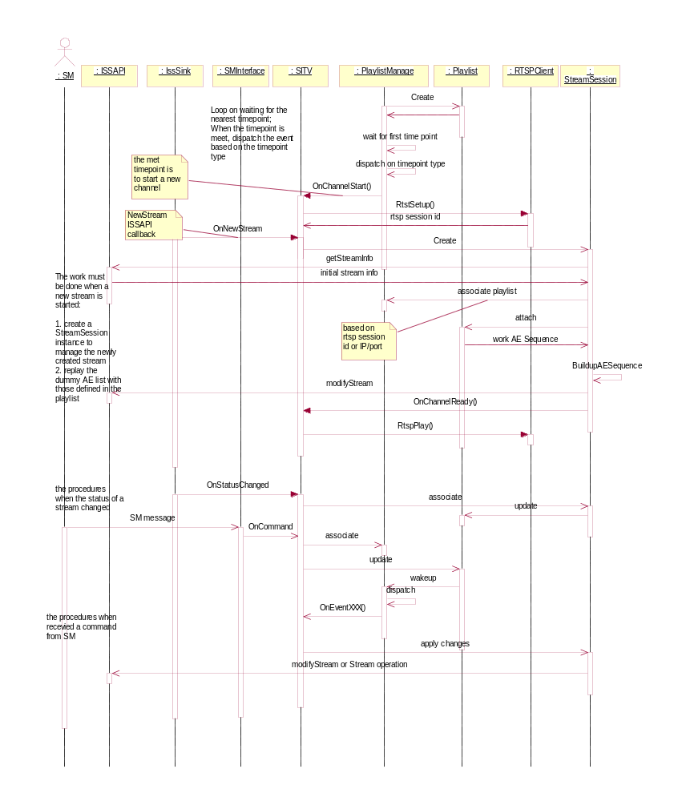

PlaylistManager Control Loop
Sleep and wakeup on playlist timepoints
- PlaylistManager is waiting for timepoint event
- Once a timepoint event is met, it dispatch the excution routine based on the timepoint types, and
- It also re-scans the playlists to determine the nearest timepoint to sleep
- Sleep till the newly calculated timepoint

Playlist Modification
- Any playlist modification by the service or SM command will fire a timepoint event to wake up the PlaylistManage Control loop to re-fresh the nearest timepoint

SM command process
- The SMInterface received a command message from SM, parse it
- The Service SITV process the command
- Associate to an active playlist instance if the command is playlist-oriented
- Apply the updates to the playlist
- Wake up the playlistManager control loop and refresh the nearest timepoint

Launch a Channel
This is a timepoint-event process
- The playListManager waked up on a start-a-channel timepoint and fire OnChannelStart() event call to the service
- SITV calls RTSPClient to send RTSP SETUP request
- The RTSPClient response with a newly created RTSP session ID, keep the RTSP session ID in the playlist instance
- ISSAPI fires a OnNewStream() event call from its callbacks
- SITV create a new StreamSession to bind this stream
- The StreamSession get some initial details about the stream
- The StreamSession associate the related playlist instance managed by the PlaylistManager with the information of IP+port or RTSP session ID
- The StreamSession attach itself to the playlist with bi-direct links
- The StreamSession build up the real AE list to play based on the playlist setting
- The StreamSession calls ISSAPI to apply the playlist-defined AE list to the stream
- The StreamSession fires a OnChannelReady() event call to the service
- The service calls RTSPClient to send a RTSP PLAY request

Responses Stream Status Changes
When the stream is ongoing, SeaChange Stream Server notices the related components about it status. The program trace this changes to keep the playlist status up-to-date.
- IssSink fires a OnStatusChanged() event call from its callbacks
- The service associate the related StreamSession instance via Stream Identification
- The StreamSession instance update its own status and the related status information in its attached playlist status
- The playlist instance wakes up the PlayListManager control loop if necessary.
- Sends status change message to SM if necessary thru SMInterface

Keep Alive and Failover Process
Service failures
The service maybe failed due to various reasons. SITV will include a failover process to deal with the exceptions. The failover appoarch will be implemented in two parts:
- SITV inherit from SeaChange's service framework to keep itself alive by sending health signals to svcshell.exe. svcshell will force to restart the service if it could not receive such signals for a period.
- The playlist is mirrored to database (a set of disk files in a specified folder in the first release) and managed by PlaylistManager.. The update applied to the playlist will be flushed into the mirrored database
Once the unique PlaylistManager instance is initialized whenever the service starts, it will scan the database (the folder of mirrored files) and bring up playlist instances about to play.
PlaylistManager relocated the position to start in such playlist based on the current time or the stream content.
Those recovered playlists will be place into the regular playlistmanager control loop and be processed as well as others
Stream failures
For the stream-level failures, SITV sinks Callback(StreamStatusChange) to detect. When a OnStatusChange() event is fired, SITV responses the stream failure by appending the process in the step 3 of the above section Responses Stream Status Changes. SITV dispatches based-on different of failure cases. The following are the possible stream failure types that are going to handle:
Failure | Description
STRMTERM | Stream is terminated
STRMEND | Stream has reached the end during play
STRMABORT | Stream is aborted
STRMLOSTCONN | Stream lost connection with SS, Recover or Reconnect will come later // Recover or Reconnect will come later
RCVRYBEGIN | Recovery begins for a particular SS
RCVRYEND | Recovery ends for a particular SS
For STRMTERM, STRMEND and STRMABORT, the above step 3 will verify the channel status with all the playlist associate to it, and see if there are any content AE remains based on the current time. It will set a immediate timepoint and build up a continue-to-go AE list if there are any, otherwise, it call up the filler to build up a filler list. Then it wakes up the playlist manage control loop to force the stream pumped.
STRMLOSTCONN, RCVRYBEGIN and RCVRYEND are ignored currently in the first release and will take no actions.
Of course, we can only call such stream-level failover process approach as “ineffective” because the service was noticed by ISSAPI when problem happens. It will be better if we have our own “effective” logic to diagnose. However, since all “getStreamStatus()”s are not functional currently in ISSAPI, plus directly scanning the out-going streaming traffic will raise system load and engineering load too much, we are going to implement the “ineffective” first at this moment.

Output
Provide a detailed description of expected output from this function, including any error conditions that may occur.

Scheduled Stream
The SITV drives ITV system to pump stream out base on the scheduled playlist.

RTSP Requests
SITV also works as a RTSP client. It starts a new stream by sending a RTSP SETUP request followed by a RTSP PLAY.
The RTSP requests are term service based, and implemented in RTSPClient. Please see SeaChange Interactive Television Real Time Streaming Protocol Client Interface Specification for more details on the extended protocol.

RTSP heartbeats
When a RTSP session is established, it is required to keep sending heatbeat messages to the server to make the session alive. SITV sends blacklines as the heartbeat signals

Detailed and leveled log messages

Modules

Playlist, PlaylistManager and Playlist DB

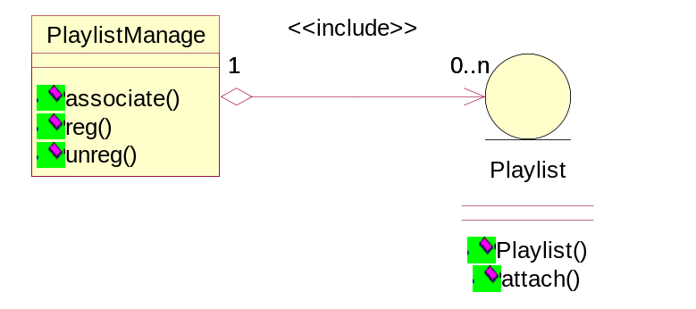
Playlist represent the definition of a schedule for a single channel. This module includes two major types of objects: playlist and PlaylistManager. The detailed module design about the class diagram and internal sequence will be covered in the PLAYLIST AND PLAYLIST MANAGEMENT Module Design Document by Bernie Zhao.
The playlist is an entity class to
- Keep a sequence of assets/asset elements to play on a specified channel.
- Keep the current status reflects the associated ongoing stream
- Mirrors the data in the external database, which will be implemented as an XML formatted text file in this release. The mirrored disk files will keep the ongoing playlist information and the dynamic status date of the stream
The playlist manager manages all the active playlist instances in memory. It also
- Response the queries for a playlist.
- When the service starts, the playlist manager scans the local database to load the uncompleted playlists to recover the channel
- Playlist manager is the source to fire the time point- based event to wake up the playlist manager loop

PlaylistManager Primary Exports:

STVPlaylist * createList (const char * mirrorfile = NULL )
create a new playlist (maybe from a DB mirror file)
Parameters:
mirrorfile the DB mirror file used to create, including full path
Returns:
pointer to new playlist, or NULL if failed

DWORD STVPlaylistManager::extract (unsigned long critAssoci,
unsigned long critPlay,
std::vector< STVPlaylist * > & outlists
)

extract playlists which are about to setup
Parameters:
critSetup the time criteria used to extract pool for SETUP
critPlay the time criteria used to extract pool for PLAY
outlists the output, containing all the extracted lists
Returns:
the minimum time for next sleep

int STVPlaylistManager::getPlaylists(std::vector< STVPlaylist * > & outlists)
get all playlists currently in pool
Returns:
a vector containing all playlists

int STVPlaylistManager::OnNewPlayList(ZQ::common::IPreference * pPortPref,
ZQ::common::IPreference * pPlayListPref,
int nType
)
create a new playlist according to information provided, and register it
Parameters:
pPortPref the pointer to an XML structure containing info about Channel
pPlayListPref the pointer to an XML structure containing info about playlist
nType the type of playlist, one among LISTTYPE_BAKKER, LISTYPE_PLAYLIST, LISTYPE_FILLER
Returns:
error code; STVSUCCESS if create successfully

Playlist Primary Exports:

SYSTEMTIME STVPlaylist::getNextTime()
get the begin time of this playlist
Returns:
the begin time with format as SYSTEMTIME

int STVPlaylist::getPLchannel()
get playlist channel information
Returns:
the channel id Definition

int STVPlaylist::getPLStatus()
get playlist current status
Returns:
the current status of playlist

AutoFiller and BarkerFiller
When there are some time segments without asset or asset element definitions, the filler subsystem will fill those time segments with elements in a pre-defined asset set.
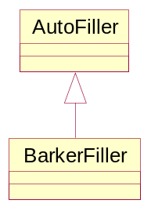
Based on where the filler is invoked, the filler can be defined as AutoFiller and BarkerFiller.
- AutoFiller involves for the undefined time segments, it picks up some asset elements to fill those time segments. AutoFiller supports
  - serialized ordering, and
  - randomized ordering
for the elements.
- BarkerFiller is used in the barker system. It inherints all the functionalities from the AutoFiller, and it has more co-work with the playlist objects on channel-related information

Primary Exports:
void fill(ASSETNODELIST * playList,
FILLTYPE type,
DWORD duration
)
fill the play list with fillers
Parameters:
playList - IN/OUT pointer of playlist that will be filled in
type - IN describle in FILLTYPE.Now FILLTYPE_SERIAL or FILLTYPE_RANDOM
duration - IN the time autofiller will fill in.(second)

Schedule Manager Connector
The connector is the interface to exchange data with Schedule Manager, the UI subsystem. It is implemented mainly in the class SMIntefaces. For the connection between the service and SM, SM works as the server-side and SITV works as the client-side. In other words, SITV establishes connection to the SM server. See issue#37 and SM Interface with Ingest and Playback for more details:
- The connector establishes a TCP connection to the SM server
- The messages past thru the connection will be XML based, the messages covers all the interaction between SITV and SM. See SM Interface with Ingest and Playback, 1.0.4 for more details.
- The connector builds up the out-going messages, and
- parses the incoming messages
- For the incoming messages, the connector dispatch on the commands and fires events calls to SITV, the main object of the service, to response
- When the connection is dropped, the connector will be responsible for covering the connection by keep retrying periodly
The detailed module design about the class diagram and internal sequence will be covered in the SMInterface Detailed Design Document.doc by Jie Zhang.
Primary Exports:
void CSMConnector::SendStatusFeedback(const char * sContent)
send status Feedback
Parameters:
[in] sContent status information content(<message>'s sub node content)

int CSMConnector::SendData ( const char * sBuf, int nLen )
send data to SM
Parameters:
[in] sBuf data address to send
[in] nLen data length to send
Return values:
errSuccess if success, other for error

Primary Event to Fire:
The connector receives messages from SM, the fires the event calls exported from the main control:
int OnNewPlayList (IPreference *pPortPref, IPreference *pPlayListPref, int nType)
int OnPlayAssetImmediately (IPreference *pPortPref, IPreference *pPlayListPref)
int OnHoldAsset (IPreference *pPortPref)
int OnPlaySkipToAsset (IPreference *pPortPref, IPreference *pPlayListPref)
int OnPlayFillerImmediately (IPreference *pPortPref)
int OnQueryStatus (IPreference *pPortPref)
int OnChannelStartup (IPreference *pPortPref)
int OnChannelShutdown (IPreference *pPortPref)
int OnConfigration (IPreference *pConfigPref)

RTSP Client
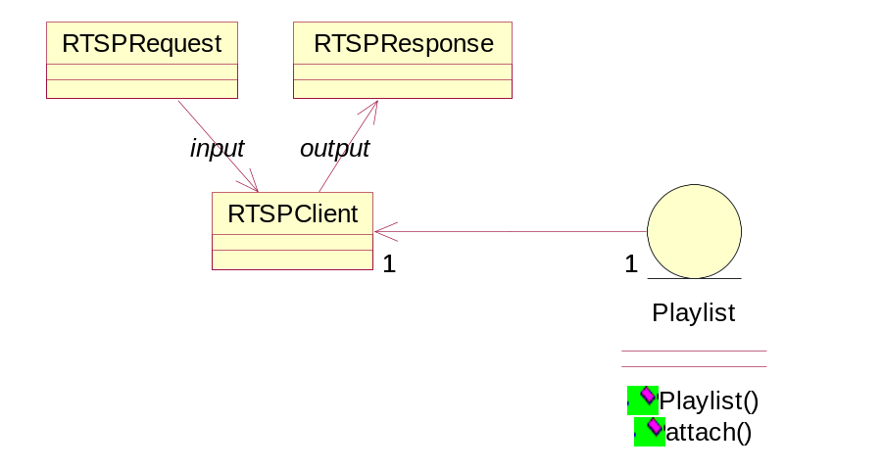

The RTSP client is the launcher to start the stream on a specific channel. Any active playlist will associate with one RTSPClient instance. The RTSPClient
- Establishs the connection to the RTSP server implementation embedded in ITV connection manager
- Signals to keep the connection alive
- Send the RTSPRequest to the RTSP server
- Fires event calls to the SITV server main class when the RTSPResponse arrives
RTSPRequest and RTSPResponse build up RTSP message headers and bodies based on the RTSP specification, see RFC 2326 - Real Time Streaming Protocol and SeaChange Interactive Television Real Time Streaming Protocol Client Interface Specification (DRAFT) Revision 1.5.0 for more detail. They
- Parse the streamed data
- Provide user to set and get any header field
- Implement the SeaChange extensions on RTSP protocol such as node group
- Has a mechanism to convert a multicast IP address to faked MAC address

The detailed module design about the class diagram and internal sequence will be covered in the RTSP CLIENT CONTROL MODULE (RTSPCLIENT) Module Design Document by Bernie Zhao.

Primary Exports:
For RTSPRequest/RTSPResponse
std::string getHeaderField(std::string name)
Returns a header field value based on its name
Parameters:
name field name
Returns:
field value or "" if not found

void setHeaderField (std::string name, std::string value)
Sets a header field value based on its name
Parameters:
name field name
value field value

For RTSP Client
void send (RTSPRequest request, RTSPResponse& response)
Sets a header field value based on its name
Parameters:
Request the request message to send
response the response message expected to receive

Stream Session
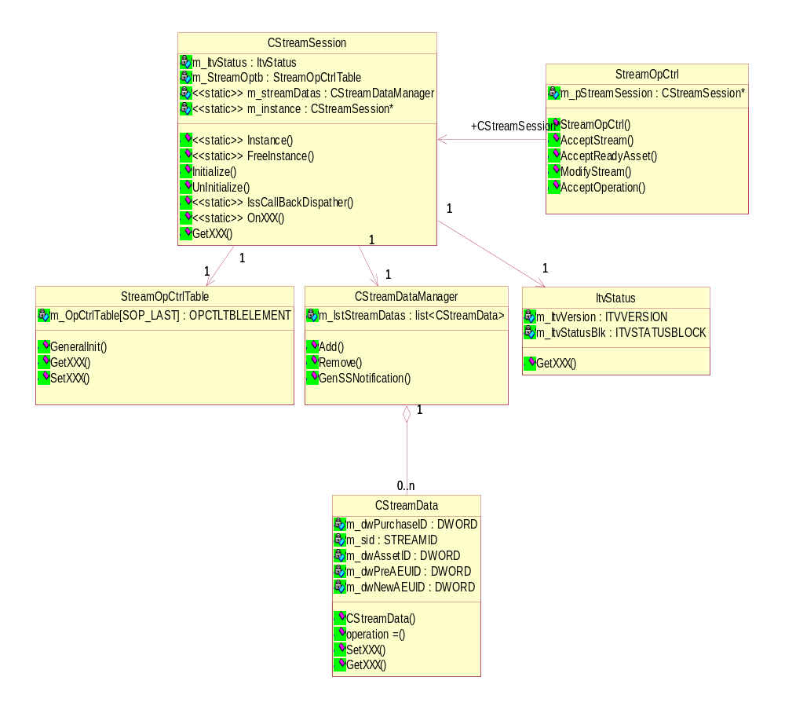
When a stream is brought up, ITV SS assigns a unique id for it. In SITV, a StreamSession object is created to associate this stream. The StreamSession covers:
- All stream operation controls such as play, pause, stop for the stream
- Build up a new AE list based on the playlist to replace the initial AE list, which is a dummy list to initial for each channels
- Every active stream session will associate with a playlist instances via channel-oriented information, SITV can address the playlist instance from a stream session instance bi-directly.
- SITV sinks the SS events and dispatch to target StreamSession based on StreamID. The major events must be sinked in SITV are:
          - When a stream is about to be created
          - When the AE list for a stream is updated
          - When the status of a stream is changed
- [Enhance] When the status of a stream is updated, the SITV compares the status of a on-air stream with the playlist items, realtime modify the stream to adjust to match the playlist definition if necessary
- [Enhance] When a realtime update command message against an on-air playlist arrived, the SITV modify the associated stream by invoking the ISSAPI

Module Sequence Diagram
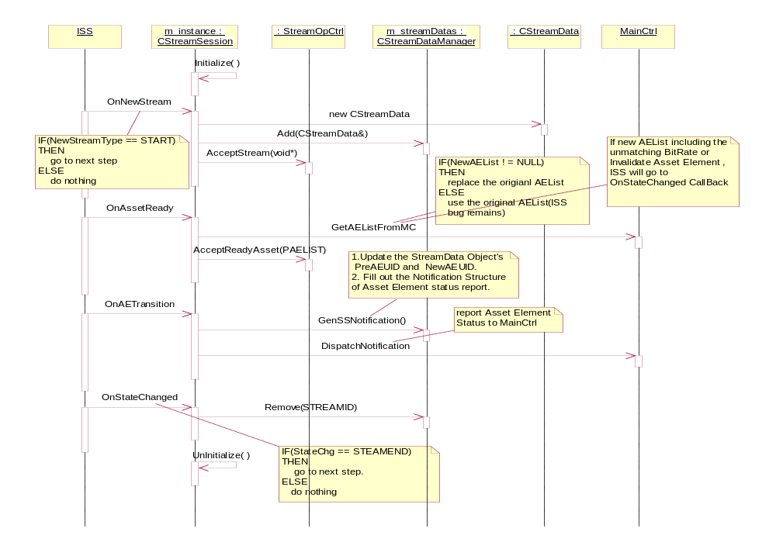
Primary Event to Fire:
The connector receives messages from StreamSession, the fires the event calls exported from the main control:
int OnStreamStatusChanged (CStreamSession *pStream, int nType…)
int OnStreamError (CStreamSession *pStream, int nType…)

SeaChange Service Framework

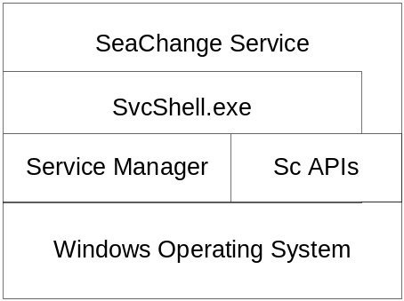

The SITV service will be distributed as a SeaChange standard ITV application service. Its service framework will cover:
- Svcshell.exe redirects the Windows NT service entry points. SITV implements the entries defined in AppShell.lib
- Uses the CfgPkg as its primary configuration IO interface
- Uses the CReporter as its log subsystem
- Supports the interactions with SeaChange manUtil.exe to provide a management user interface
- Supports the interactions with SeaChange SysMon service
- Uses SeaChange pooled thread definition

Installation and Documentation
TBD.

Error Codes
TBD

Maintenance Utility Description

ManUtil
As a Seachange style service, SITV can be managed via ManUtil.exe.
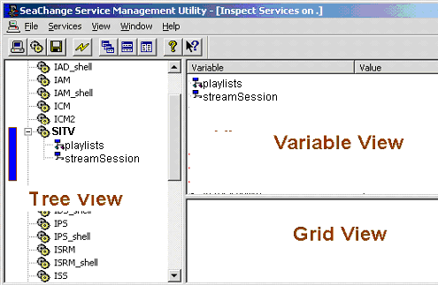]
At the top node of the SITV service, the variable view will reflect all configuration variable defined in Service Configuration section:
name | description
MirrorDirectory | The first release of SITV use a set of disk files as the mirrored database for the playlists.  This configurable option let administrator to specify where to put the mirror files
MirrorFileExtname | The file extenstion name of the mirror files
FillLength | The number of minutes that a playlist will be filled by the filler
ScheduleManangerAddr | The IP address where the Schedule Manager Service installed
ScheduleManangerPort | The port number that the Schedule Manager Service listens
InstanceID | The INST id of the SITV installation
ApplicationUid | The application UID when the SITV registered to the AM
RTSPServerAddr | The IP address where the ISRM installed
RTSPServerPort | The port number that the ISRM serv as a RTSP server-side
RTSPFrequence
RTSPTimeout | Timeout to waiting for a RTSP response
DummyAssetUid | To specify the dummy asset to bring up a stream

Addtionally, the SITV node will include several complex variables such as the active playlists, streamsessions and channels to show the runtime status.

Installation and Deployment

Installation Automation

Deployment and Pair Backup

What information appears on the GUI will be changed according to the requirement from the customer, this section just a sample to give a general idea.

